Pastor Richard Allen Farmer
The Crossroads Church
5587 Redan Rd.
Stone Mountain, GA 30088
The Last Words of Jesus, Part 2
Into All the World
Text: Mark 16:14-15
The disease is called xenophobia (Greek word, phobus= fear; xenos=stranger).
It is defined as a fear or hatred of strangers, foreigners or people who are different.
The opposite of xenophobia is xenophilia- attraction to strangers, foreigners or people who are different.
We have seen, in our world, far too much xenophobia and far too little xenophilia.
Witness:
  - The Holocaust. Between 1941 and 1945, Adolph Hitler ordered the extermination of six million Jews simply because they were different.
- The Ku Klux Klan and its murders of people of color simply because they are different.
- The pandemic of 2020. Political leaders started calling the COVID-19 virus, “the Wuhan virus” or “the Chinese virus”. On May 8, 2020, United Nations Secretary-General Antonio Guterres said that “the pandemic continues to unleash a tsunami of hate and xenophobia, scapegoating and scare-mongering” and urged governments to “act now to strengthen the immunity of our societies against the virus of hate.” (hrw.org)[Human Rights Watch].
Xenophobia is irrational. It is based on ignorance, in the truest sense of the word. Xenophobes do not know about the group of whom they are afraid. Over against this irrational fear and hatred of others, comes the Great Commission.
Some writers suggest that the Great Commission was given to Jesus’ eleven disciples and they became the first apostles, the sent-out ones. Those writers go on to say that it is not suggested in the text, that we the Church, are to hear this commission as applying to us.
In an article published in Christianity Today (June 12, 2019) titled, The Church Does Not Exist for the Sake of the World, Mark Galli writes,
We automatically apply this verse to all Christians and to the church in general, equating as we do the calling of the original disciples with our calling. But in a larger reading of the New Testament, this command is actually only given to the eleven disciples. It’s the point at which the disciples—learners of Jesus—become apostles, those “sent out” to tell others about Jesus. These eleven very much become the first apostles.
But not every Christian is called to be an apostle.

Even if we agree with Galli and his interpretation of the last words of Jesus, it is clearer, from a larger reading of the New Testament, that we are to care about people. Even if we don’t see Jesus’ commission as a command which applies to the church today, making Christ known is still our ultimate goal. Jesus dares us- no, commands us- to be interested in others. We are not only to be interested in them. We are to engage them.
Why should a believer in Jesus take a keen interest in others?
Wouldn’t we be justified in taking good care of our own, and only our own?
Shouldn’t we leave people to themselves and let people of every ethnicity reach their own kind?
I offer four compelling reasons to reach across racial and ethnic lines to present the gospel.
- Every person God created is valuable.
Genesis 1:27
So, God created man in His own image; in the image of God, He created him; male and female He created them.

- Every valuable person whom God created has the right and deserves the privilege of hearing the life-changing message of God in Christ.
“No one has the right to hear the gospel twice, while there remains someone who has not heard it once.”- Oswald J. Smith

3. Some people will not or cannot be reached from inside their group. They must be reached by outsiders.
4. People who are not given an opportunity to receive the Christ are in spiritual peril.

John 3:36
He who believes in the Son has everlasting life; and he who does not believe the Son shall not see life, but the wrath of God abides on him.”

1 John 5:12

He who has the Son has life; he who does not have the Son of God does not have life.

We, the bearers of the message of Jesus, see the entire world as our ministry field, our parish, our audience. We cross whatever lines exist. We cross ethnic, social, socio-economic, and cultural lines in order to present Christ to every person. Not all will say “yes” to Christ, but many will. Since we do not know who will receive Christ and who will reject the Savior, we present Christ to the whole world.
Even if this commission in Mark 16 was to apply only to the original followers of Jesus, it’s a good starting point for the rest of us. Why limit ourselves? Why not spread this good news as far as possible?
Preaching to all of Stone Mountain or Atlanta is a good idea. To all the world is an even better idea.
According to joshuaproject.org there are 7,422 unreached people groups in the world. That is, there are 7,422 ethnic groups who have not one page of scripture in their heart language. They have not heard of this One who spoke to the eleven as they reclined around a table (Mark 16:14)
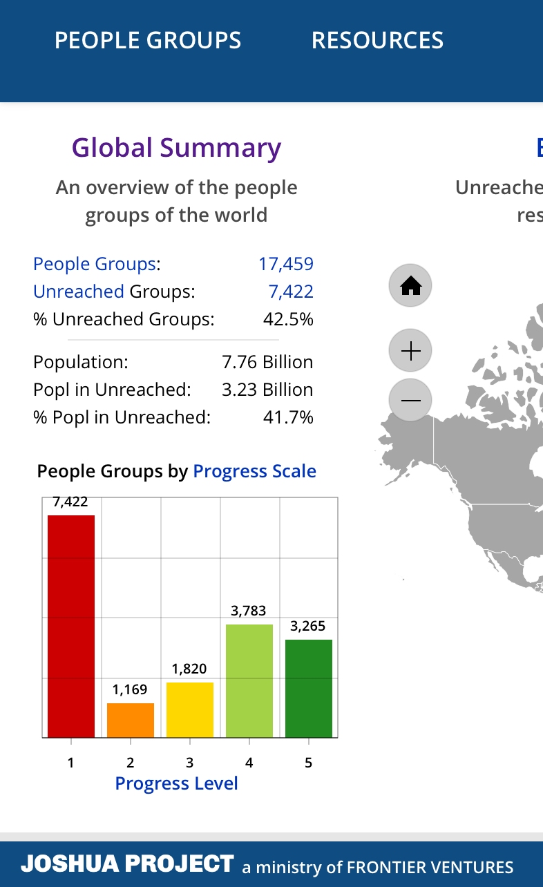
From joshuaproject.net-

We have a compelling story to tell.
Q: To whom do we tell it??
A: To the nations. To the whole world.
This story is so good we dare not localize it. Instead, we GLOCALIZE it. Remember that word? I used it some months ago in a sermon. It is a combination of global and local.
We who proclaim Christ do not only proclaim him in the safety of the cities and cultures with which we’re most comfortable. We hear Jesus’ command and we take this message to other cultures and other cities and other language groups and other nations and other tribes and other others!
Go!!...into all the world. Why? Because Jesus commanded it. Even if Jesus wasn’t talking to you when He said it, it’s a mighty good idea. 7,422 people groups would thank you.
Amen

