Pastor Richard Allen Farmer
The Crossroads Church
5587 Redan Rd.
Stone Mountain, GA 30088
Series- Immanuel: God With Us
Part 4: God With Us in Jesus the Christ
Text: Matthew 1:23; John1:1-5, 11-14

While this is a strong prologue and opening to the gospel, I think John’s statement of why he wrote the gospel is even stronger. It is in 20:30-31.
And truly Jesus did many other signs in the presence of His disciples, which are not written in this book; but these are written that you may believe that Jesus is the Christ, the Son of God, and that believing you may have life in His name.
This 14th verse of John contains a statement about the Christ that can be life-changing. This one verse tells us the precise benefit of Jesus coming to earth.
There are two nouns and two verbs in verse 14 that I wish to examine.
- The Word- (first noun)- Jesus is the logos of God. Jesus is God’s ultimate thought, God’s rationale, God’s articulation to the world.
- Became- (first verb)- change of status; the entering into another condition; to be born.
A scholar named Du Toit puts it this way:
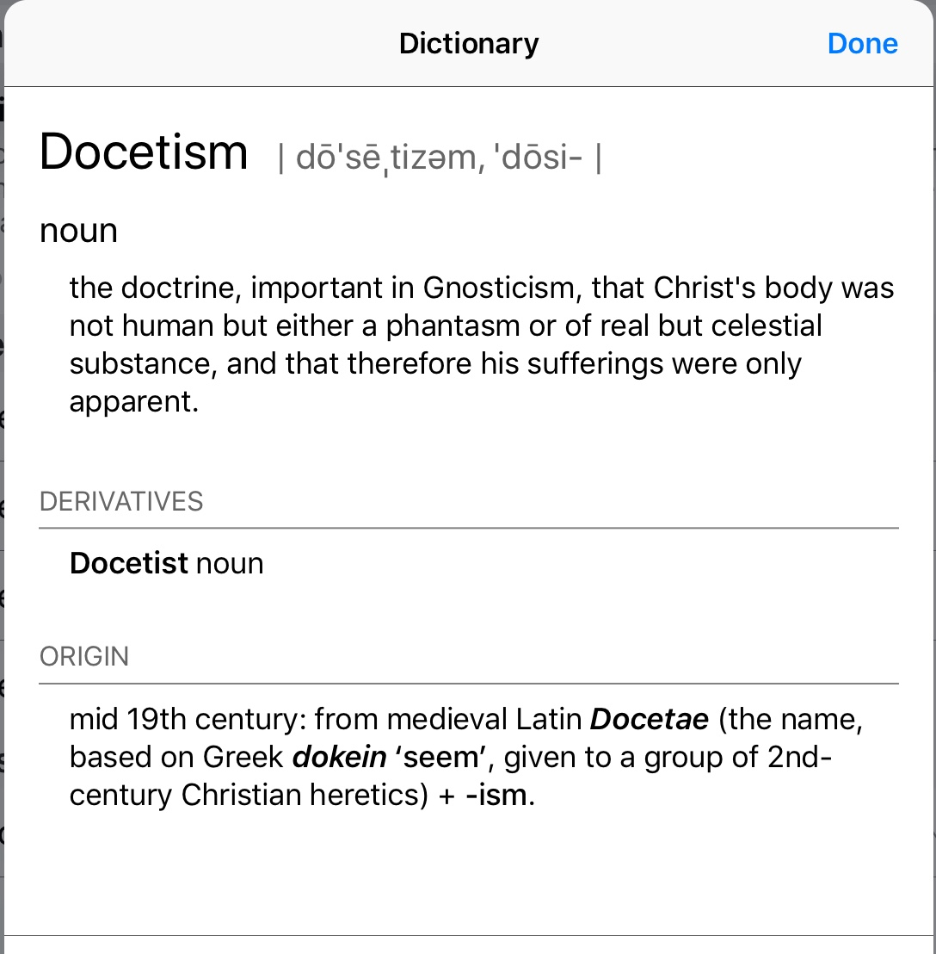
The incarnation means, according to verse 14, that the divine Logos substituted his heavenly way of existence for the frail, broken, earthly, human way of existence. This human existence of the Word is not to be understood in a docetic way, a mere being “in the flesh”, but as a “becoming flesh,” and yet without sacrificing his essential being as Logos.
John is, in verse 14, making a frontal, direct response to the heresy called Docetism.

- Flesh- (second noun)- human; our state; the ultimate identification with us; Christ became like us so that, through faith in Him, we might become like Him.
- Dwelt- (second verb)- Christ took up residence in flesh. Much as God tabernacled with Israel, Jesus tabernacles with us in His coming in flesh. Cf. Exodus 40:34.
14
The Word became flesh and blood,
and moved into the neighborhood. - The Message

Illus.
Pastor Walter Hoye went to jail in April 2009 for standing too close to an Oakland, California abortion clinic during a protest. The prosecutor gave Hoye the choice of accepting a stay-away order or two years in jail. Hoye refused the offer and the judge sentenced him to 30 days in jail. Hoye is not sorry for his choice. In fact, he sometimes wishes he could have stayed in jail longer. “I have been a jail chaplain in jail before, and even had the privilege of being a guest preacher at San Quentin. Being an inmate is completely different. I was actually one of them and it gave me a different kind of credibility.” --World Magazine, May 9, 2009 p. 54.
In the Christmas event, Jesus became one of us and it gives Him a different kind of credibility.

Closing
Jenna cried out to her mother from her bedroom, "Mommy, I’m afraid to be in my dark room alone." Her mother replied, "It’s okay, Jenna. The Lord is with you." Jenna called back, "Yes, but I want someone with skin on." Jesus is God "with skin on." And He has come so that we never have to be afraid again.

Immanuel.

God with us.

With skin.

Amen

Neotestamentica, 15-16, pp. 16-18

