Pastor Richard Allen Farmer
Crossroads Church
5587 Redan Rd.
Stone Mountain, GA 30088
770.469.9069
No Ordinary Joe, Part 19
“So Joseph Died”
Text: Genesis 49-50
Parents are often the glue that holds a family together. When that last parent dies, often those adult children scatter.
So it was with Jacob, later named Israel. The fact that was alive, comforted the sons of Jacob as they were reintroduced to their brother Joseph. I think they thought that as long as daddy was alive, Joseph would hurt them. Now Jacob is dead, and the brothers wonder out loud,
“Perhaps Joseph will hate us, and may actually repay us for all the evil which we did to him”(50:15).
Joseph, however, is not in vengeance mode. The brothers send to Joseph, a messenger with a fabricated, unnecessary message: “Before Daddy died, he requested that you forgive us”. The brothers begin to grovel (50:18). Neither the made-up message from their late father nor the groveling are necessary, for Joseph is way past the need to get even.
The book of Genesis ends with a lengthy account of Jacob’s family (37:2-50:26). In chapter 48, Jacob blesses his grandsons, Ephraim and Manasseh. In chapter 49, Jacob pronounces blesses and curses on his twelve sons. Jacob has also made Joseph promise not to leave his bones in Egypt. “Bury me where my forbears are”, Jacob asks (47:27-31; 49:29-32). It is after the death of Jacob, the patriarch that held the clan together, that the situation gets a little dicey. What will become of these brothers?
This text contains good news. It would be easy and tempting to play God after one’s patriarch head is dead. “Daddy’s no longer here. I am in charge.”
Illus.
On March 30, 1981, President Ronald Reagan was shot by John Hinckley. President Reagan’s Secretary of State, Alexander Haig, stood at a press briefing while Reagan was hospitalized and declared, “I am in control here”.
That was not true. In the event of the president’s incapacity, the order of succession is vice president, speaker of the House of Representatives, president pro tempore (“for the time being”) of the Senate and then Cabinet secretaries.
Al Haig seemed too eager to assume a place that was not his.
Joseph does not act Haig-like. Father is dead but Joseph doesn't quickly put himself in that place.
Let me suggest that Joseph:
- Knew his place. (50:19)
True, Joseph has risen in power and authority in Egypt, but he knows his place. Joseph is not God and Joseph knows it. Revenge was part of the culture in which Joseph lived. Joseph’s scheming, conniving father, Jacob, tricked his father into giving him the blessing that should have gone to Esau, the firstborn son of Isaac. In Genesis 27:41, we read
So Esau hated Jacob because of the blessing with which his father blessed him, and Esau said in his heart, “The days of mourning for my father are at hand; then I will kill my brother Jacob.”.
Joseph’s brothers are thinking Joe could make a similar statement. “Now that Daddy’s dead, let’s kill these brothers,”.
W. Sibley Towner states:
Among the many things that scripture means when it speaks of the fear of God is this. It means refusing to put my plans or your plans or even Pharaoh’s plans in the place of God’s plan. (Genesis, p.289)
Joseph knows his place!
2. Knew his brothers (50:20a)
3. Knew his God (50:20b)
BUT GOD!!!!! I have suggested earlier in this series, that there are least two agendas at work here. The brothers of Joseph are working evil and God is working all things together for Joseph’s good. It doesn't feel that way at times. The work of God overrides the work of human. Why is evil permitted to have even a little impact? Why doesn’t God just shut it all down?
Illus.
We recently experienced the murder of one of our church family members. A legitimate question, raised by the member’s family and us, would be, “Why does God allow evil to run seemingly rampant?” I have no definitive answer.
However, Joseph makes it clear, as he processes his own story, that he believes God is at work, even while evil seems to also be at work. In nearly every event in our journey, there is evidence of human handling and, sometimes, mishandling. There is also evidence that The Eternal is at work. Recall with me, that line in 45:5: you sold me...God sent me. In Luke’s version of the Sermon on the Mount, in Luke 6:27-31, Jesus gives an ethical stance, a way to conduct ourselves, in the face of evil.
27 “But I say to you who hear: Love your enemies, do good to those who hate you, 28 bless those who curse you, and pray for those who spitefully use you. 29 To him who strikes you on the one cheek, offer the other also. And from him who takes away your cloak, do not withhold your tunic either. 30 Give to everyone who asks of you. And from him who takes away your goods do not ask them back. 31 And just as you want men to do to you, you also do to them likewise.

4. Knew his own mortality (50:24)
“I am dying”. So realistic. He had a lived a full life. 110 years (50:22). Lived to see his children, grandchildren and great grandchildren (50:23). He lived to see three generations of his son, Ephraim: 4 levels down. Joe lived a full life. Sold at seventeen. Probably spent three years in prison. Spent approximately thirteen years in service to Potiphar. Was thirty years old when he entered Pharaoh’s employ (41:46). H died at 1110 years old. That’s eighty years of service. Long career. However, eventually we die.

Illus.
John Ortberg tells the story of playing Scrabble with his grandmother. One time he won a game with her and was feeling quite proud of himself. His grandmother put the tiles back in the box and reminded John that whether we win or lose, at the end of the game all the pieces go back in the box. The game is over for Joseph and all the pieces, including Joseph’s bones, go in the box!
Just as Joseph’s father, Jacob, made Joe promise to carry Jacob’s remain back to Canaan, Joseph made the Israelites promise the same (50:25).
5. Knew of a promise (50:24)
Joseph knew of a something else. He knew there was a promise made to his forbears that was to be fulfilled in the future. Later, it would be Moses who would take the bones of Joseph, on the journey to the land of promise (Exodus 13:17-22). Later, Joshua would inter the bones at Shechem (Joshua 24:32). Without using the language of eternal life, or heaven, or promised land, Joseph states that God is not finished with Joseph’s brothers or the larger Israelite people group. God is going to do something else!
Hebrews 11:22 declares Joseph to be one who acted in faith.
By faith Joseph, when he was dying, made mention of the departure of the children of Israel, and gave instructions concerning his bones.
So Joseph died. Full life. Over now.
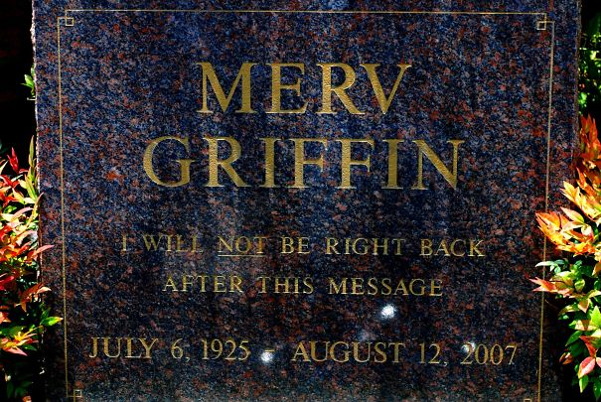
If we were to write a few lines on a headstone for Joseph, what would those lines be?
I have heard of some rather memorable engravings:
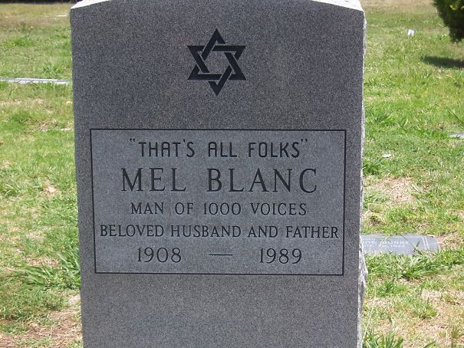

If Joseph had an engraving on a headstone, which he does not, what would it say?
Favored by his father
Hated by his brothers
Sold by his brothers
Tempted by Mrs. Potiphar
Imprisoned by Potiphar
Forgotten by a butler
Remembered by God
Reunited with his brothers
Reconciled to his brothers
And then he died!
The end.
Maybe not.
Amen

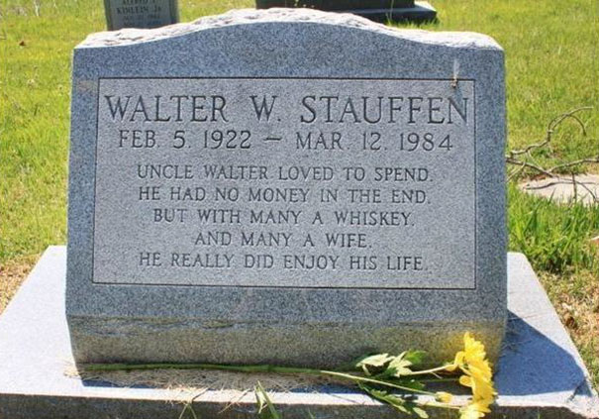
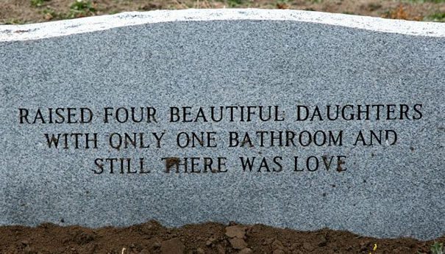
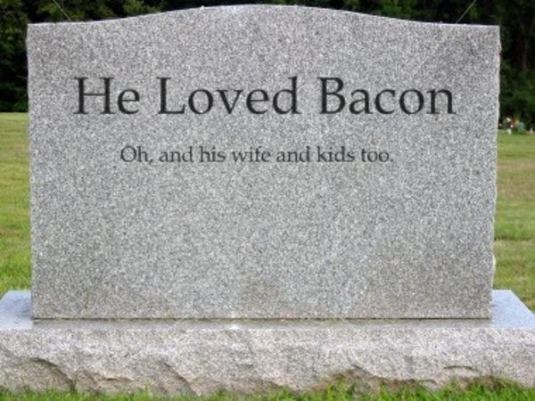
Appointed by a Pharaoh

