Pastor Richard Allen Farmer
Crossroads Church
5587 Redan Rd.
Stone Mountain, GA 30088
770.469.9069
Oh, the Blood
Text: Hebrews 9:11-22
Some words are completely unnecessary at the beginning of a sentence. In public discourse today, one of those words is so. People use it at the beginning of a sentence as if it is the continuation of a previous thought, which it usually isn’t.
“So, Christy and I went shopping yesterday. We both bought iPhones”.

However, when the writer begins this sentence with but, it is significant. There is a contrast, here, between an old covenant and a new.
Just before our text, describing the old covenant and the frustrations of it, the writer writes,
9 It was symbolic for the present time in which both gifts and sacrifices are offered which cannot make him who performed the service perfect in regard to the conscience— 10 concerned only with foods and drinks, various washings, and fleshly ordinances imposed until the time of reformation.

Christ did not come empty-handed. This text says this High Priest came with the greater and more perfect tabernacle, which is, according to v. 11, not earthly.
Christ entered the Most Holy Place, again, not empty-handed. Most of us have used and heard the phrase, once and for all. Here in v. 12, that phrase finds its ultimate use. What Christ did, in his substitutionary death was an act that he did once and for all (7:27; 10:10). That phrase suggests two truths worth celebrating:
- Jesus’ sacrificial death was sufficient. So sufficient, that he need only die once. (ONCE)
- It was also universal in both its implication and its application. (FOR ALL)
There is, by this anonymous theologian/writer of this epistle, an argument from the lesser to the greater. Here is the logic: if the blood of bulls and goats and the ashes of a heifer could make one feel somewhat clean and forgiven and spiritually squared away, how much more could the blood of Christ cleanse us? Here are the elements and rituals used and enacted by mortals, on the one hand. Here are the greater elements and acts of the perfect Son of God, on the other hand. If the lesser is even a bit effective, how effective would the greater be?
Because of that act of Christ giving himself, his theological title changes. He came as High Priest (v. 11) and is now the Mediator (v. 15) of a new covenant. Two covenants- first and second or old and new.
A valid question: Why did Christ have to die? Here the writer switches metaphors and uses legal language. I hope all of you have a will. A will is a legal document in which a person states who should receive his or her assets after he or she dies. The will does not go into effect until the testator dies (v. 16). A will is a simple paper, legal document while the testator lives. A will is a piece of paper that has no power...until a death occurs. That’s when the will kicks in.
V. 18-22: A rehearsal/reminder of the first covenant.
Earlier, in 8:7-13, the writer describes the first covenant as having faults, defects, limits, inadequacies.

The common element between the old and new covenants is blood.
Blood had to be shed. Blood equals life (Leviticus 17:14).
Animal blood and Christ’s blood contrasted:
- Animal blood had to be carried into the holy of holies. Christ entered the holy of holies himself.
- Animal blood sacrifices had to be repeated. Christ gave himself once and for all.
- Animal blood sacrifices could only cover sin; Christ’s blood actually takes sin away and cleanses us (v. 14; John 1:29 [The next day John saw Jesus coming toward him, and said, “Behold! The Lamb of God who takes away the sin of the world!”; 1 John 1:7 [But if we walk in the light as He is in the light, we have fellowship with one another and the blood of Jesus Christ His son cleanses us from all sin.] ).
Old and new covenants contrasted:
- Old covenant was written on parchment. New covenant is written on the hearts of believers (8:10; 2 Corinthians 3:1-3)
- Old covenant is temporal. New covenant is eternal (9:15).
When some hear the phrase, the blood of Christ, they think, “gory”. We think, glory!
When some hear the phrase, the blood of Christ, they think, “vicious”. We think, victory.
When some hear the phrase, the blood of Christ, they think, “misery”. We think, mercy
When some hear the phrase, the blood of Christ, they think, “distress. We think, deliverance.
In the United States, AB-negative is considered to be the rarest blood type, and O-positive the most common. The Stanford School of Medicine Blood Center ranks blood types in the United States from rarest to most common as follows:
- AB-negative (.6 percent)
- B-negative (1.5 percent)
- AB-positive (3.4 percent)
- A-negative (6.3 percent)
- O-negative (6.6 percent)
- B-positive (8.5 percent)
- A-positive (35.7 percent)
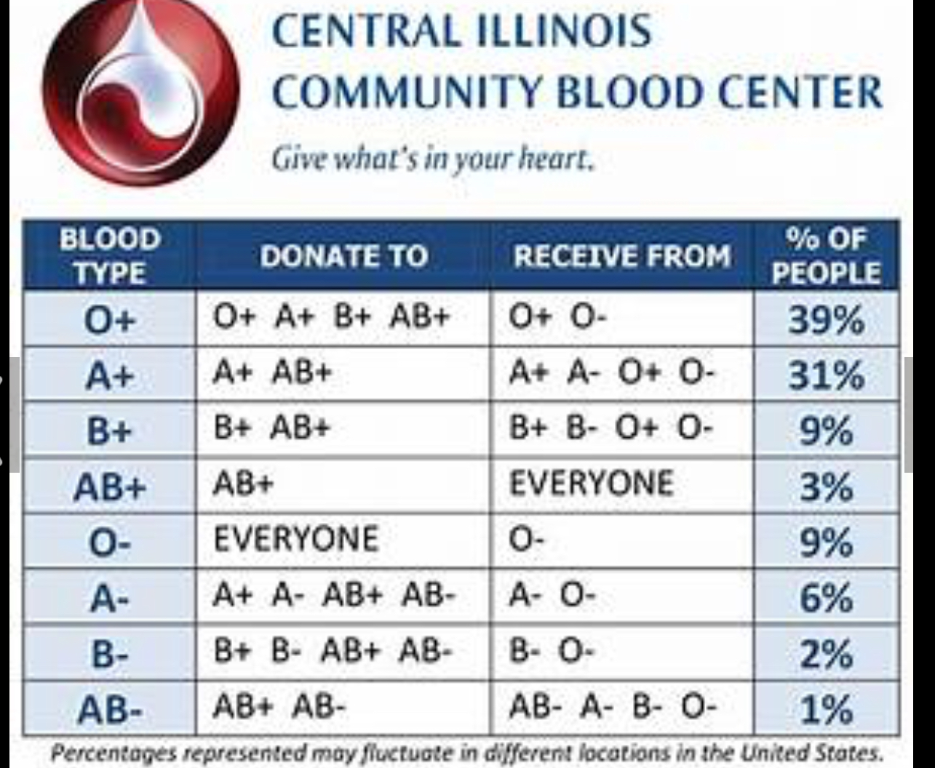
- O-positive (37.4 percent)

There could come a day when the blood I need is unavailable to me. I would need a donor whose blood type is compatible with mine. Not so with the blood of Jesus. That blood can cleanse the sin of any person, of any type, of any ethnicity, of any personality type, of any ilk, of any race, of any proclivity, of any leaning, of any size, of any age, of any size, of any skin color.
Beloved, there is a fountain filled with blood. Anyone who places herself/himself beneath that blood will be cleansed from every stain.
That fountain flows freely to all who would say “yes” to the Christ.
We leave here today simply celebrating the sacrifice of Christ, which was necessary for our salvation. Oh, God, thank you for the Christ who took on the death I should have endured. Thank you for the blood- sufficient and universal.
Closing
Chorus (key of F or G)
Oh, blood of Jesus!
Oh, the blood of Jesus
Oh, the blood of Jesus, t
Oh, the blood of Jesus
It washes white as snow
Amen

