Pastor Richard Allen
Crossroads Church
5587 Redan Rd.
Stone Mountain, GA 30088
770.469.9069
Faithing Our Fears
Text: Psalm 56:3-4

This text begins with an assumption that offends me.
Even though it is spoken by the psalmist, it makes fear sound inevitable. As a tough New Yorker, I do not wish to admit that I am ever afraid! Psalmist, what do you mean by “whenever”? How about never? Let’s allow that the psalmist has a right to speak his mind and admit his fears.
How should such fears be handled?
This text suggests at least two options when it comes to handling the circumstances of life.
- Go at life from the vantage point of fear
- Go at life from the vantage point of trust
Fear is something that is too difficult for some to even admit they have. We have been told we must be courageous and not afraid. We must take life by the throat and master it before it masters us. Yes, that’s it. We will tell life who’s in charge. We will take on those matters which would lesser people afraid. The scriptures teach that God has not given us a spirit of fear, but of power and of love and of a sound mind. (2 Timothy 1:7).
Illus.
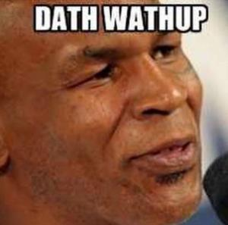
Sir Isaac Newton suffered from agoraphobia (fear of open or public spaces) and was housebound for many years. Danish writer Hans Christian Andersen had a lot of phobias. He was afraid of dogs. He didn’t eat pork because he worried he would contract trichinae (tri-‘ki-nee), a parasite that can be found in pigs. He kept a long rope in his luggage while traveling, in case he needed to escape a fire. He even feared he would accidentally be declared dead and buried alive, so before bed each night, he propped up a note that read, “I only appear to be dead.” (mentalfloss.com). Fears.
Illus.
This week I read of a group in England called TOP (Triumph Over Phobia). The group will periodically take a trip to the Manchester Airport and members of the group address their fears there. At the airport there’s something for everyone. There are small spaces and big ones. There are elevators for the claustrophobics to try. One member who is a social phobic, was sent to all the car rental agencies and had to talk to a person at each counter and find the best rental deal for that day (Helen Saul. Phobias: Fighting the Fear, p.131).
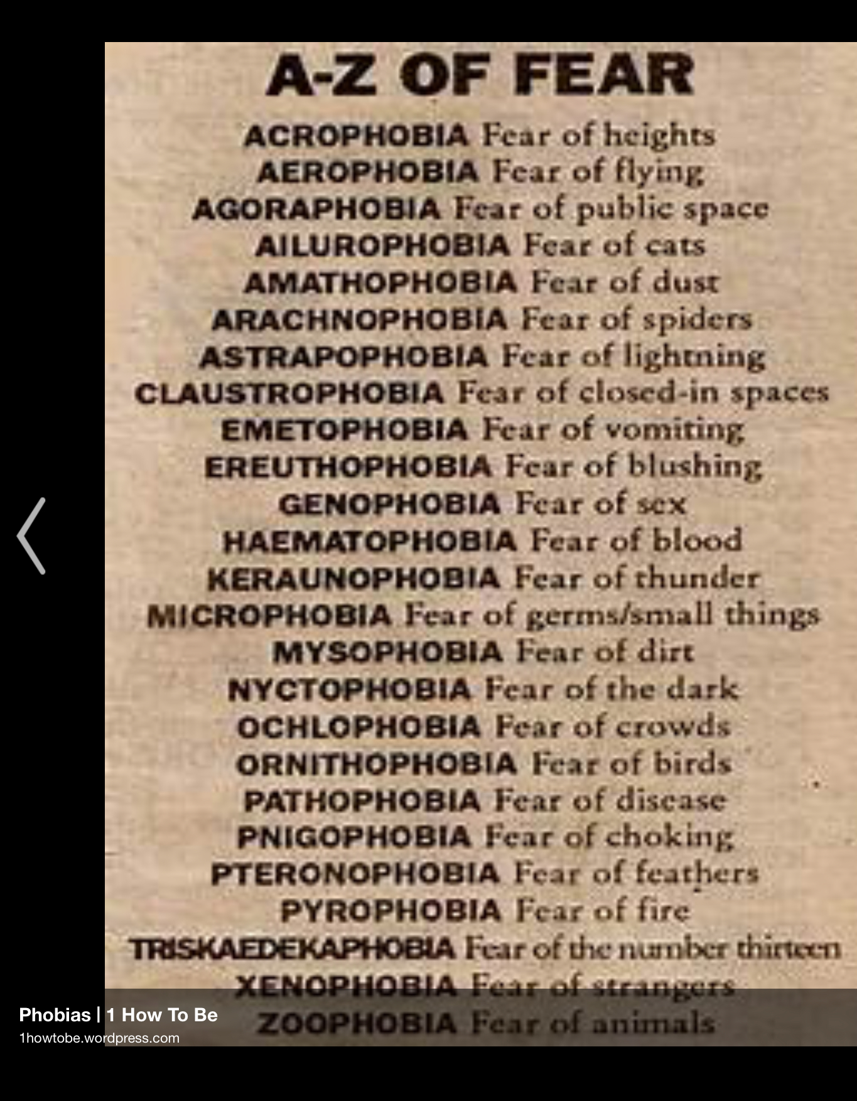
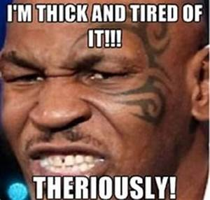
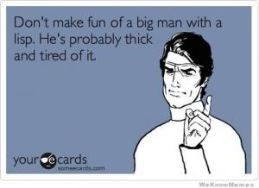

Illus.
Boxer Mike Tyson is famous not only for his fighting but for his lisp. Tyson has launched a new line of t-shirts, tank tops and sweatshirts featuring the slogan 'Thun’s Out, Guns Out' - a nod to the practice of taking any opportunity to show off your muscles in glorious weather.(dailymail.co.uk. By ANDY WARREN FOR MAILONLINE. PUBLISHED: 18:23 EST, 29 July 2016 | UPDATED: 18:37 EST, 29 July 2016
With a nod to Tyson and all other lispers, I want to suggest a practical approach to fear: Faith it. Yes, we should FACE our fears, but we should also FAITH them That is, apply trust in our God, to our fears.
Trusting is a childlike attribute. To be trusting is to believe that the one to whom you have been handed will not let you down.
Illus.
Cave diver Jill Heinerth said, I’m actually risk averse...I think it’s important to be scared. (AARP Bulletin. November 2019, p. 46)
Maybe one benefit of fear is that it might drive us to trust. Whether we are in a therapy group, on a field trip to the airport, to work on our phobias, or we are in worship, thinking of the circumstances that frighten us- let us apply our faith to our fear.
There are those who conspire to make us afraid. They aim to put fear in us. What can such people, ultimately, do to us? It is the question of verse 4. The answer is, NOTHING. We are God’s children and we who trust in God can be delivered from outrageous, life-controlling alarm and fear and panic.
This sounds insultingly simple. Just say “no” to fear? The Hebrew verb, to fear is yare’(yaw-ray’). It is the verb used when God reminds Abram of who Abram is following: ...the Lord came to Abram in a vision, saying, “Do not be afraid, Abram. I am your shield, your exceedingly great reward.”
Sometimes when we are afraid, that’s all we need to hear.

We say “no” to being afraid, we must also say ‘yes” to trust in God. The Hebrew word for trust is batach (baw-takh’). It means in Hebrew what it means in English: to express confidence in.
Psalm 9:10
And those who know Your name will put their trust in You. For You, Lord, have not forsaken those who seek You.
We know God’s name. Therefore, we ought not live in fear!!!!!

Go from this place, fully aware that there are problems to be handled and giants to be encountered. Shall we cower in the corner? Shall we go into our houses never to come out again? Shall we let a panic attack sideline us?
No, we shall look at our enemies, our dilemmas, our struggles and our failures and we shall FAITH them!!
Amen

