Pastor Richard Allen Farmer
Crossroads Church
5587 Redan Rd.
Stone Mountain, GA 30088
770.469.9069
Worth From Waste
Text: Matthew 15:21-28
Did you ever feel so pulled upon that you wanted to withdraw and get away from EVERYBODY? Maybe it was at a family reunion. Perhaps it was a recent visit from your children and grandchildren. They were all laughing, talking, maybe screaming and squealing and the television was on and you? You just wanted to go into your room and close the door.
That’s Jesus in this text. In Mark’s account of this story (Mark 7:24) Mark writes that Jesus “entered a house and wanted no one to know it, but He could not be hidden”. As much as Jesus tried to, He could not escape from the people who wanted and needed His attention.
Back in Numbers 13:29, we are informed that the residents of this area by the sea and along the banks of the Jordan were called Canaanites. The Jesus who cannot be hidden is approached by a Canaanite woman. She has an interesting request. She has heard of Jesus and His work, His miracles, His compassion. She asks, “Have mercy on me”.
She lays out her problem of a demonically-possessed daughter. I was sure that the Jesus I knew would immediately show compassion. I pictured Jesus embracing the woman. But no. Jesus, who has the ability to literally change this woman’s daughter’s life, says NOTHING! (23a). Silence from the Son of David???
Son of David, a messianic title (9:27; 20:30-31)

The disciples are not silent, like Jesus, but are no more helpful. Sometimes we think being verbal is always the right response to awkward silence. Suppose what you say is worse than the silence. Jesus says nothing. The disciples speak.
They suggest that this woman be sent away. She is a bother, an annoyance. An intrusion. A diversion. She has needs and we can’t have that. After all, we have ministry to do. We cannot be bothered with a woman who has needs and a request. Jesus did not answer the woman but He does directly answer the disciples.
Jesus answers them, using the language of exclusion (10:6).
Jesus implies that He is not available to everybody. This Jesus who is speaking here is not the Jesus I thought I knew so well. My Jesus does not go silent when a need is expressed (v.23a). My Jesus certainly does not say He only came to serve Americans or people from the United Kingdom or Whites or Asians or Blacks or Latinos or people from Buckhead or people from Fayetteville or people who are in the one percent or people who are homeless or people who are formally educated or people who are illiterate. This twenty-fourth verse disturbs me, as it shows a Jesus who is not everybody’s deliverer.
After the woman prays one of the shortest prayers on record, “Lord help me!”, Jesus adds another insulting line: “It is not good to take the children’s bread and throw it to the little dogs”.
What an insult! The healing this woman desires is so valuable, it is called “the children’s bread”. The woman is so little thought of that she and her needy daughter are referred to as dogs.
I like this woman’s comeback.
Illus.
Some great comeback lines:
- When I die, I want my epitaph to read, “Mistakes were made.”
Wasn't that already on your birth certificate?
- Son: Mom, stop, you’re not funny, you never make jokes.
Mom: I made you!
- Noel Coward (English playwright) vs. Edna Ferber(novelist/playwright):
Coward: You look almost like a man.
Edna Ferber: So do you.
- George Bernard Shaw (Irish playwright) vs. Winston Churchill (British Prime Minister)
Shaw: Have reserved two tickets for opening night. Come and bring a friend, if you have one.
Churchill: Impossible to come to first night. Will come to second night if you have one.
- Dorothy Parker (writer, poet, satirist) to Calvin Coolidge (30th president of the USA): ”Mr. Coolidge, I’ve made a bet against a fellow who said it was impossible to get more than two words out of you.”
Calvin Coolidge: “You lose.”
This woman’s comeback is no less biting and sharp and even witty.
“Alright, let’s agree that my daughter and I are dogs (Greek= kynarian- tame house-dog; puppy). Even dogs, get crumbs. Can a sister get a crumb?” This wasn't necessarily an insult on Jesus’ part. It certainly was, however, a faith statement on the woman’s part.
What sounds like another request is actually a statement of faith. This woman believes that if she doesn't receive all Jesus’ attention, a little will do. If she doesn't come to know all His power, a portion of it will suffice. This woman is thinking that, given who Jesus is, a crumb will do. This woman is not trying to jump the line. “The Israelites are to get the blessing of the Christ first and then the Gentiles? Fine, just give me some crumbs”.
From the ground, on which crumbs (the waste from the children’s bread) are thrown, comes value and worth.
We can gain much from a little of Jesus. A parallel thought is in the story of the woman who touched the hem of Jesus’ garment (Matthew 9:20-22; Mark 5:25-34; Luke 8:43-48). To believe that simply being near Jesus and receiving even a bit of what He offers will be good for us, is a statement faith. Jesus rewards both women in these two narratives, with healing.
In our text, here in Matthew 15, Jesus tells the woman that her faith is great (Greek word=megas; loud, out of the ordinary in degree, size, effect) and that the desired healing of her demon-possessed daughter, will be granted.
Some of us have sought out the Christ who could not be hidden. We have seen His power and long to see it operant in our lives. We have heard that He came, offering the children’s bread and we have wanted to receive what He offers. We have cried out to the Son of David and He has heard us. Some in this room have had a more intimate experience with Jesus than others. Some have dined, up close, with Jesus. Others have been on the edges and have just gotten the crumbs. But a crumb from Jesus is better than a whole loaf from the evil one. Out of those crumbs comes that which is of infinite worth. There is great value, great worth in what, to some, is refuse!!!
Illus.
Terracycle is an innovative recycling and manufacturing company. They recycle diapers (for the Brits, nappies).
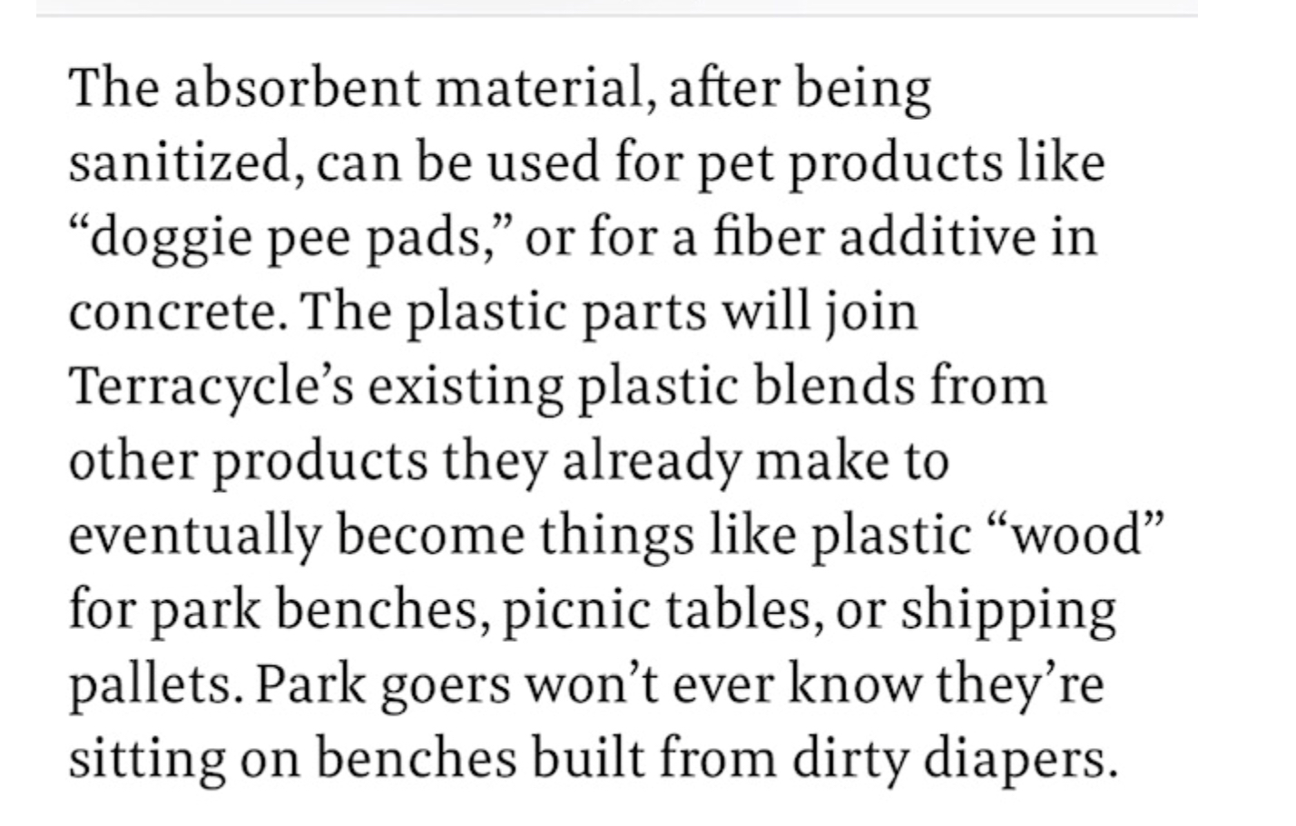
The relationship which we thought would nurture us, like bread, turns out to be crumbs but even there, the One who is the Bread of Life sustains and nourishes us. Hallelujah!
This One who could not be hidden, shows up and turns our waste into worth, our trash into treasure, our crumbs into crowns.
Amen

