Pastor Richard Allen Farmer
Crossroads Church
5587 Redan Rd.
Stone Mountain, GA 30088
770.469.9069
Short Beds and Narrow Covers
Text: Isaiah 28:20-22
The description of the people of Israel in this text could very well be used to describe our culture in North America in 2019.
Note three behaviors:
- They, lacking a firm foundation, act hastily, without deep thought given to their actions or the consequences of those actions (16).
- They lack absolute standards (17). That is, they operate from a point of relativity. A carpenter/contractor analogy is used here. A ten-inch line is not whatever the carpenter thinks it is. It is what the measuring line says it is. A straight line is not whatever the house builder says it is. The straight line is determined by the plumb line.
A plumb line will show when we’re off center, not straight.
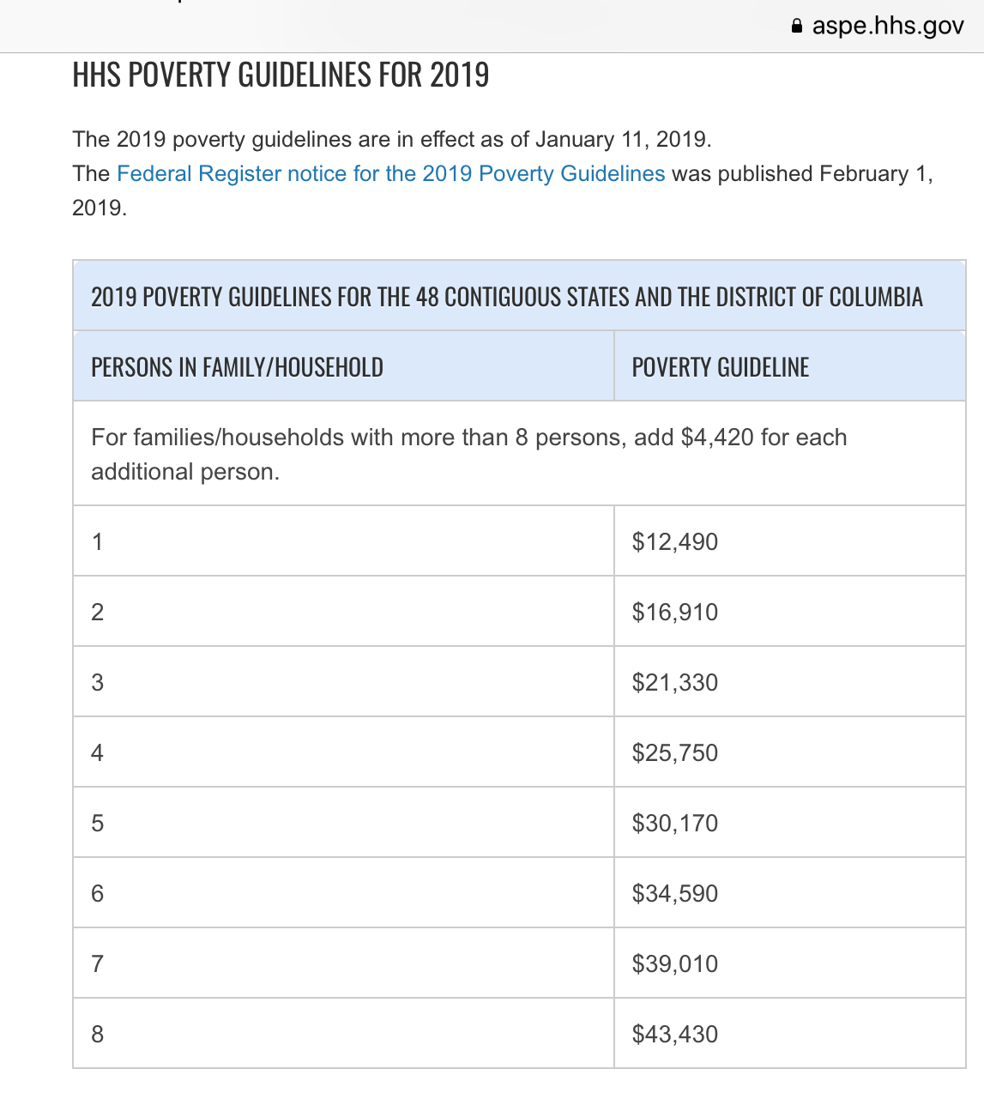
Governmental agencies are telling us we’re doing well, but we are not straight. We’re deluding ourselves.

Illus.
The official poverty rate is 12.3 percent, based on the U.S. Census Bureau’s 2017 estimates. That year, an estimated 39.7 million Americans lived in poverty according to the official measure. According to supplemental poverty measure, the poverty rate was 13.9 percent. (https://poverty.ucdavis.edu/)

When we give ourselves to the non-negotiable absolutes of God, the lies in which we have taken refuge (17) and the hiding places in which we have sequestered ourselves, will be swept away.
- They made covenants with death (15,18). There were some in Isaiah’s day and there are some in ours, those who would rather die than live.
Illus.
A disturbing article in the Washington Post (March7, 2012) notes that Russia has the third-highest teenage suicide rate in the world, just behind Belarus and Kazakhstan and three times the rate in the United States. On an average day, says the article, five Russians under the age of twenty take their own lives. A Russian psychotherapist said, “At this age, they don’t have a concept of death.... They often think there’s something heroic about it. But they also think there’s a start-over button somewhere.” That sounds like the people of Isaiah’s day.
When the great God of Isaiah, the Father of our Lord Christ, comes in to a life, these behaviors, and many more, are reversed.
Application
1.To those who pride themselves on creating their own life, God offers a cornerstone, a sure foundation.
2. To those who have no standards, God offers, Jesus, the Truth.
3. To those who have made a covenant with death, God offers Jesus Christ, the Life. This Christ offers life (John 10:10).
God offers a cornerstone, a sure foundation, a standard (a measuring line called justice).
God also offers a cancellation of a contract(covenant) that God’s people have made. It is a covenant with death and with Sheol.
The people need to get over themselves. The language of verse 20 is the ultimate articulation of human insufficiency and inadequacy. The bed on which they have stretched themselves is too short to accommodate them. Picture their feet hanging off the bed like some six foot 10 inch athlete sleeping in a 6 foot bed. The blankets with which they have tried to cover themselves are too narrow to keep the chill of their rebellion and disobedience at bay

Illus.
I watched an excellent lecture online last week. It was Daniel Goleman, speaking on Focus: The Secret of High Performance and Fulfillment (YouTube). He told of a school in New Haven, CT, in which there hangs a poster of a stop light in every classroom: red light, yellow light, green light. The caption on the poster says, “When you're upset, remember the stop light.” The children are reminded that before they act, they can stop (red light) and think of what they are about to do. They can think about their planned action (yellow light) and then they can do something more responsible (green light). That is not a bad idea. Today, would you see the red light of your own relationship with God? Would you stop and assess just where you are with God?
Would you now, with caution (yellow light), proceed to cancel your contract with death (green light) and receive the new life God offers? The bed you have constructed is too short. That with which you cover your nakedness is too narrow and insufficient.
Amen

