Pastor Richard Allen Farmer
Crossroads Church
5587 Redan Rd.
Stone Mountain, GA 30088
770.469.9069
Unwrapping Our Gifts Part 5
Text: Romans 12:1-6
Speaking to gifted people in whom the Spirit is at work, Paul urges these believers in Rome to:
- Present themselves
- Consider what “form” they will take.
Conform? Reform? Perform? Deform? Inform?
There is both a prohibition and an encouragement here.
Do not be conformed. That’s the prohibition. Don't take on the world’s shape.

But be transformed. There is the positive encouragement. Submit to the power of God to make you something and someone else. Be changed.
The result of that transformation will be an ability to model and demonstrate(prove) what is good, acceptable and perfect.
New thinking
- Think humbly (3)
- Think corporately (4-5)
- Think in terms of service (6-8). You have gifts. Use them.
Look at four gifts listed here.
- Service- Greek=diakonia. In 1 Corinthians 12:5, all gifts of the Spirit are described, collectively, as diakonia. Every gift is to be used in service to the Body of Christ. Yet, in this text, service is a specific spiritual gift. This is ministry to the needy; waiting a table; loving acts of hospitality. No gift is to be more prominent or considered more important or spiritual than another. Service is often a behind-the-scenes gift. yet, it is so needed in the Church.
- Exhortation- encouragement. Think of Barnabas, whom we referenced in a previous part of this series (Acts 4:36; 9:26-28).
- Giving- general and specific. All believers are to be generous (1 Corinthians 16:2; 2 Corinthians 9:7; Romans 12:13). Some believers will be given the ability to contribute their material resources to kingdom work, with cheerfulness and generosity. They will process their financial assets like industrialist R. G. LeTourneau did. LeTourneau said, “The question is not how much of my money I give to God, but rather how much of God’s money I keep.” (Mover of Men and Mountains. p.280)
- Leadership- C. Peter Wagner writes:
The gift of leadership is the special ability that God gives to certain members of the Body of Christ to set goals in accordance with God’s purposes for the future and to communicate these goals to others in such a way that they voluntarily and harmoniously work together to accomplish those goals for the glory of God.
Greek=proistamenos. To lead, to rule over, to manage. This word is used to describe one of the attributes of one who would be a bishop or leader in the Church. Those who have this gift must exercise it with diligence, eagerness and fervor.
Paul’s summary statement regarding spiritual gifts might be this:
Since we have been given gifts, act in humility,
act like people of Christ and not people of an unregenerate culture (v.1-2). Celebrate the diversity of the collective (v.4-5) and use your gifts!!
What prevents our operating in our giftedness?
How is it that we can gather every Sunday for corporate worship, have meetings and Bible studies during the week, have planning meetings for Christian events and still fail to affect the culture in which we live? Why is there often a disconnect between our profession and our practice? Our belief and our behavior? Our doctrine and our demonstration? I offer four cautions that might help answer the questions.
- Be careful not to allow your gift to rise above your God. That’s why Paul admonishes us in verse 3. A gift, especially one that is seen publicly, can make us arrogant. We cannot declare that we are great AND God is great, at the same time, out of the same mouth!
- Be careful not to disrespect diversity.
Honor the differences among us. This is the admonition of verses 4-6. Cf. Also, 1 Corinthians 12:14ff. Our diversity is not a problem. That diversity is a gift to us.
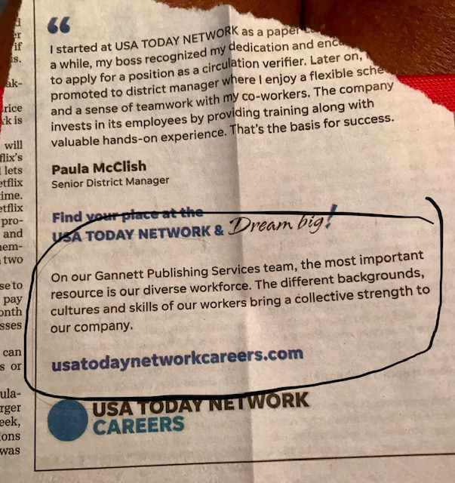
The more diverse our faith community is, the more educated we become. We learn about other traditions, practices, backgrounds, ethnicities, customs, rituals, viewpoints, perspectives, angles on a matter.
In the church, people operating in their giftedness rejoice that not all have the same gift.
- Be careful about the way you love each other. In verse 9, Paul pushes at the edges of something obvious but not talked about: hypocritical love. Paul wants to warn us that love, a word we throw around much too casually, can be phony. I should love you enough to put you and your needs above mine (v.10). I should love you enough to celebrate the differences between your gift and mine.
- Be careful about hoarding your gift. Our gifts were given to us to be used! I like the first clause of verse 6, which ends with “...let us use them”.
One of the reasons I am getting back into renting planes and SCUBA diving is because I don’t want to look at the license, the certification and have to admit, “I have the gift, the skill, the capability, the interest, the resources. I simply don’t use them.” There may come a day when I will not be able to be pilot in command of an airplane. Maybe my vision will be too poor for flying. Maybe I will suffer from hearing loss and won’t be able to communicate with air traffic control and the tower. Maybe there will come a day when I will enter the water in full SCUBA gear and I won’t be able to clear my mask, or I won’t be able to equalize the pressure in my ears. However, those days are not now. Now, I have the skills, the gifts and I am to use them. How dare we hoard, and let atrophy, the gifts of the Spirit. Use them!!!!!
Illus.
Ronald Meredith, in his book Hurryin' Big for Little Reasons, describes one quiet night in early spring: Suddenly out of the night came the sound of wild geese flying. I ran to the house and breathlessly announced the excitement I felt. What is to compare with wild geese across the moon? It might have ended there except for the sight of our tame mallards on the pond. They heard the wild call they had once known. The honking out of the night sent little arrows of prompting deep into their wild yesterdays. Their wings fluttered a feeble response. The urge to fly--to take their place in the sky for which God made them-- was sounding in their feathered breasts, but they never raised from the water. The matter had been settled long ago. The corn of the barnyard was too tempting! Now their desire to fly only made them uncomfortable. Temptation is always enjoyed at the price of losing the capacity for flight.

Saints, let’s not allow anything or anybody to take our capacity for flight away from us. We were created for worship and we were created for ministry in our area of giftedness. Let us not float on a pond of laziness or complacency, watching others fly across the sky. You have a gift.
Use it!!!
Amen

