Pastor Richard Allen Farmer
Crossroads Church
5587 Redan Rd.
Stone Mountain, GA 30088
770.469.9069
One Cross, Two Views
Text: 1 Corinthians 1:18-25

In his nineteenth century hymn, based on Galatians 6:14, John Bowring writes,

1. In the cross of Christ I glory,
Towering o’er the wrecks of time;
All the light of sacred story
Gathers round its head sublime.

2. When the woes of life o’ertake me—
Hopes deceive, and fears annoy,
Never shall the cross forsake me,
Lo! it glows with peace and joy.

3. When the sun of bliss is beaming
Light and love upon my way,
From the cross the radiance streaming
Adds more luster to the day.

4. Bane and blessing, pain and pleasure,
By the cross are sanctified;
Peace is there that knows no measure,
Joys that through all time abide.

You and I glory in the cross but ‘tis not seen by all in the same light. The non-believer and we have no disagreement on the historicity of the cross. We both agree that the crucifixion occurred. The difference is in the value attached to the cross. Our tension, if there be one, in around the issue of perspective. A perspective is a view and a point of view. It is the way one sees an object or a matter. Perspective can be physical (an aerial perspective; let’s view the model from the side and get the lateral perspective). Perspective can also be mental (let’s hear Gloria’s opinion and get the management perspective; let’s hear the worker’s union perspective).

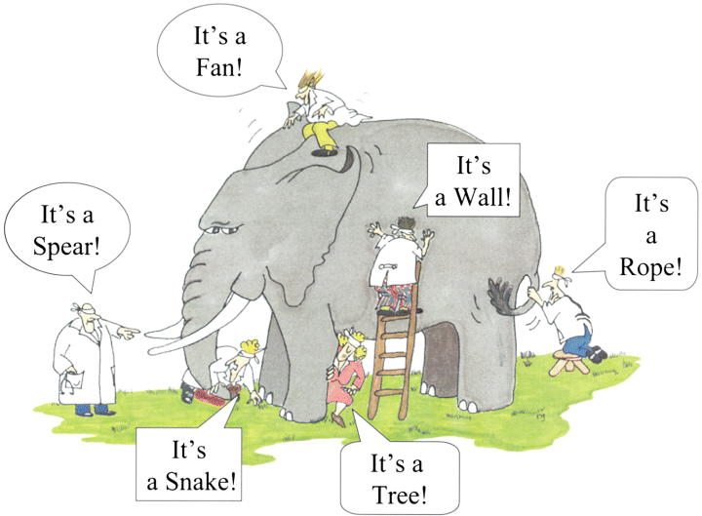
Look at this cartoon:

One elephant, six perspectives and all think they are correct. In a sense, given their perspective and the sensory information given, they are correct.

I want to examine this text by seeing a statement, a quotation, four questions, two “but”s and a summary.

The statement
“The message of the cross is foolishness to those who are perishing.” That’s a perspective, a point of view. The Greek word for foolishness is moria. The sense of that word is folly, ridiculous thought, unfounded opinion, absurdity, silly talk. Moria. We get the English word moron from this word. To some, the cross is silly, moronic. That’s one point of view and for many (the perishing), it is a valid perspective.

The quotation
Paul’s quote is from the book of Isaiah, chapter 29, verse 14. In that setting, Jerusalem has become full of themselves. God tells them He is about to do a marvelous work. Jerusalem must careful about their perspective, however. God will work, but not through the allegedly wise men from whom Jerusalem may have previous gotten their understanding.

Four questions
- Where is the wise?
- Where is the scribe?
- Where is the disputer of this age?
- Has not God made foolish the wisdom of this world?

Two “Buts”s
A. But we preach Christ crucified. The Christ of the cross!
B. But to those who are called....those who have a certain perspective on the cross...
A summary
The foolishness(moros)of God is wiser(sophos) than humanity and the weakness of God is stronger than humanity.
One cross, two views. Yes, the cross is gory, but also full of glory!
One cross, two views. To those who are perishing it is moronic. As for me,
I’ll cherish the old rugged cross
Til my trophies at last I lay down
I will cling to the old rugged cross
And exchange it someday (I don't know when that will be)
For a crown!!!
Amen

