Pastor Richard Allen Farmer
Crossroads Church
5587 Redan Rd.
Stone Mountain, GA 30088
770.469.9069
Hungering for Holiness, Part 1
Text: Leviticus 11:41-45; Deuteronomy 23:14
No, God has no zoological vendetta that He’s working out with Israel. He has nothing against specific animals. There is a broader principle here that would surely be missed if one were to simply see Leviticus merely as a list of prohibitions.
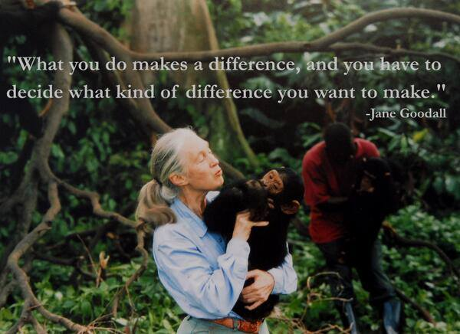
Hebrew word for holy is qadosh. It means pure, devoted, separate. I want to the word different. God’s call to holiness is a call to distinctive living. The temple was the holy temple because it was different from all buildings. The Bible is called the holy bible because it is different from all other books. The sabbath was called a holy day because it was to be different from all other days. The people of God (you and I) are holy because we are to be different from all other people. We are to be distinctive in our speech, our behavior, our beliefs.

What kind of a difference is Israel to make?
We read, in our text, of zoology, sociology and theology.
- Zoology: A description of abominable creatures (41-42). Three kinds of animals: ones that crawl on their bellies (only other reference is Genesis 3:14, in reference to the serpent in Eden), creatures that goes along on all fours and creatures with many feet (centipedes?)
- Sociology: The possibility of an Israelite becoming abominable by association/engagement (petting them, eating them?) with abominable critters (43). Sociology, by definition, is the science of social institutions and social relationships and the way a society works.
Interesting phrase- make yourselves abominable
- Theology: The holy God and His call on His people (44-45). Note that God defines and describes himself as holy (44b, 45b). Ultimately, the hunger for holiness should drive us to want to be God-like. Holy people, consecrated people, want to imitate God! We will see this self-reference to God’s holiness elsewhere in Leviticus (19:2; 20:26). God reminds Israel of his deliverance of the nation from bondage (45). That freedom from bondage is reason enough for Israel to live in holy response to this God. Why this detailed prohibition about diet? perhaps, this is a reminder to Israel that all life comes under the heading surrendered to God. Paul goes at this in a one-liner to the Church at Corinth:
Therefore, whether you eat or drink, or whatever you do, do all to the glory of God. (1 Corinthians 10:31).1

Illus.
Nineteenth century Scottish theologian John Brown:
Holiness does not consist in mystic speculations, enthusiastic fervours, or uncommanded austerities; it consists in thinking as God thinks, and willing as God wills.
Closing
This God who calls us to holiness is watching us. He watched Israel as they implemented His commands. He also watches over you and me in 2019 and challenges us to comply and to create an environment, a camp, wherein God is honored. I close with the reading of Deuteronomy 23:14. After God gives specific instructions about several possible scenarios that might disqualify a person, God says,
14 For the Lord your God walks in the midst of your camp, to deliver you and give your enemies over to you; therefore, your camp shall be holy, that He may see no unclean thing among you, and turn away from you.
May there be no unclean thing among us!!
Amen

