Crossroads Presbyterian Church
Part of the Greater Atlanta Presbytery
of the Presbyterian Church (USA)
www.crossroads-pc.com

CHURCH STAFF
Nena Simonetti Administrative Assistant 770-469-9069
Patti Matthews Choir Director 770-469-9069
Latoria Hairston Youth Director 770-469-9069
Pastor Corey Lee Dir. Family Ministries 770-469-9069

LOCAL, NATIONAL & GLOBAL MISSIONS
Richard and Amanda Coleman TMS Global - Ethiopia
Margaret Garner Worldwide Discipleship Assoc. Atlanta
Willys & Suzette Goss-Geffrard Water Mission - Haiti
Jacqueline Huggins Wycliffe Bible Translators – Philippines
Gary Lane Mission Discovery
Focused Community Strategies Atlanta
Annette Smith Georgia Missions - Southern States, USA
Tony & Veronica Warner InterVarsity Christian Fellowship – SE

CURRENT RULING ELDERS
Class of 2024 Class of 2025 Class of 2026
Ephram Curry Michael Sofidiya Deloris Rose
Pamela Gruduah Mel Walker Maggie Stewart
Judie Morgan
Nancy Scott
Susan Small
John Matthews

CURRENT BOARD OF DEACONS
Class of 2024 Class of 2025 Class of 2026
Claudette Clark Roz Fuse-Hall Sam Jones
Byron James Ruth Cosby
Adolphe Denkey Mark Brown
Valerie Henry Dorothy Jones
Deborah Miller Sandy Lewis
Bill Lambert
Lysandra Brown

5587 Redan Road, Stone Mountain, GA 30088-3203
Tel: 770-469-9069 Fax: 770-469-7002
office@crossroads-pc.com

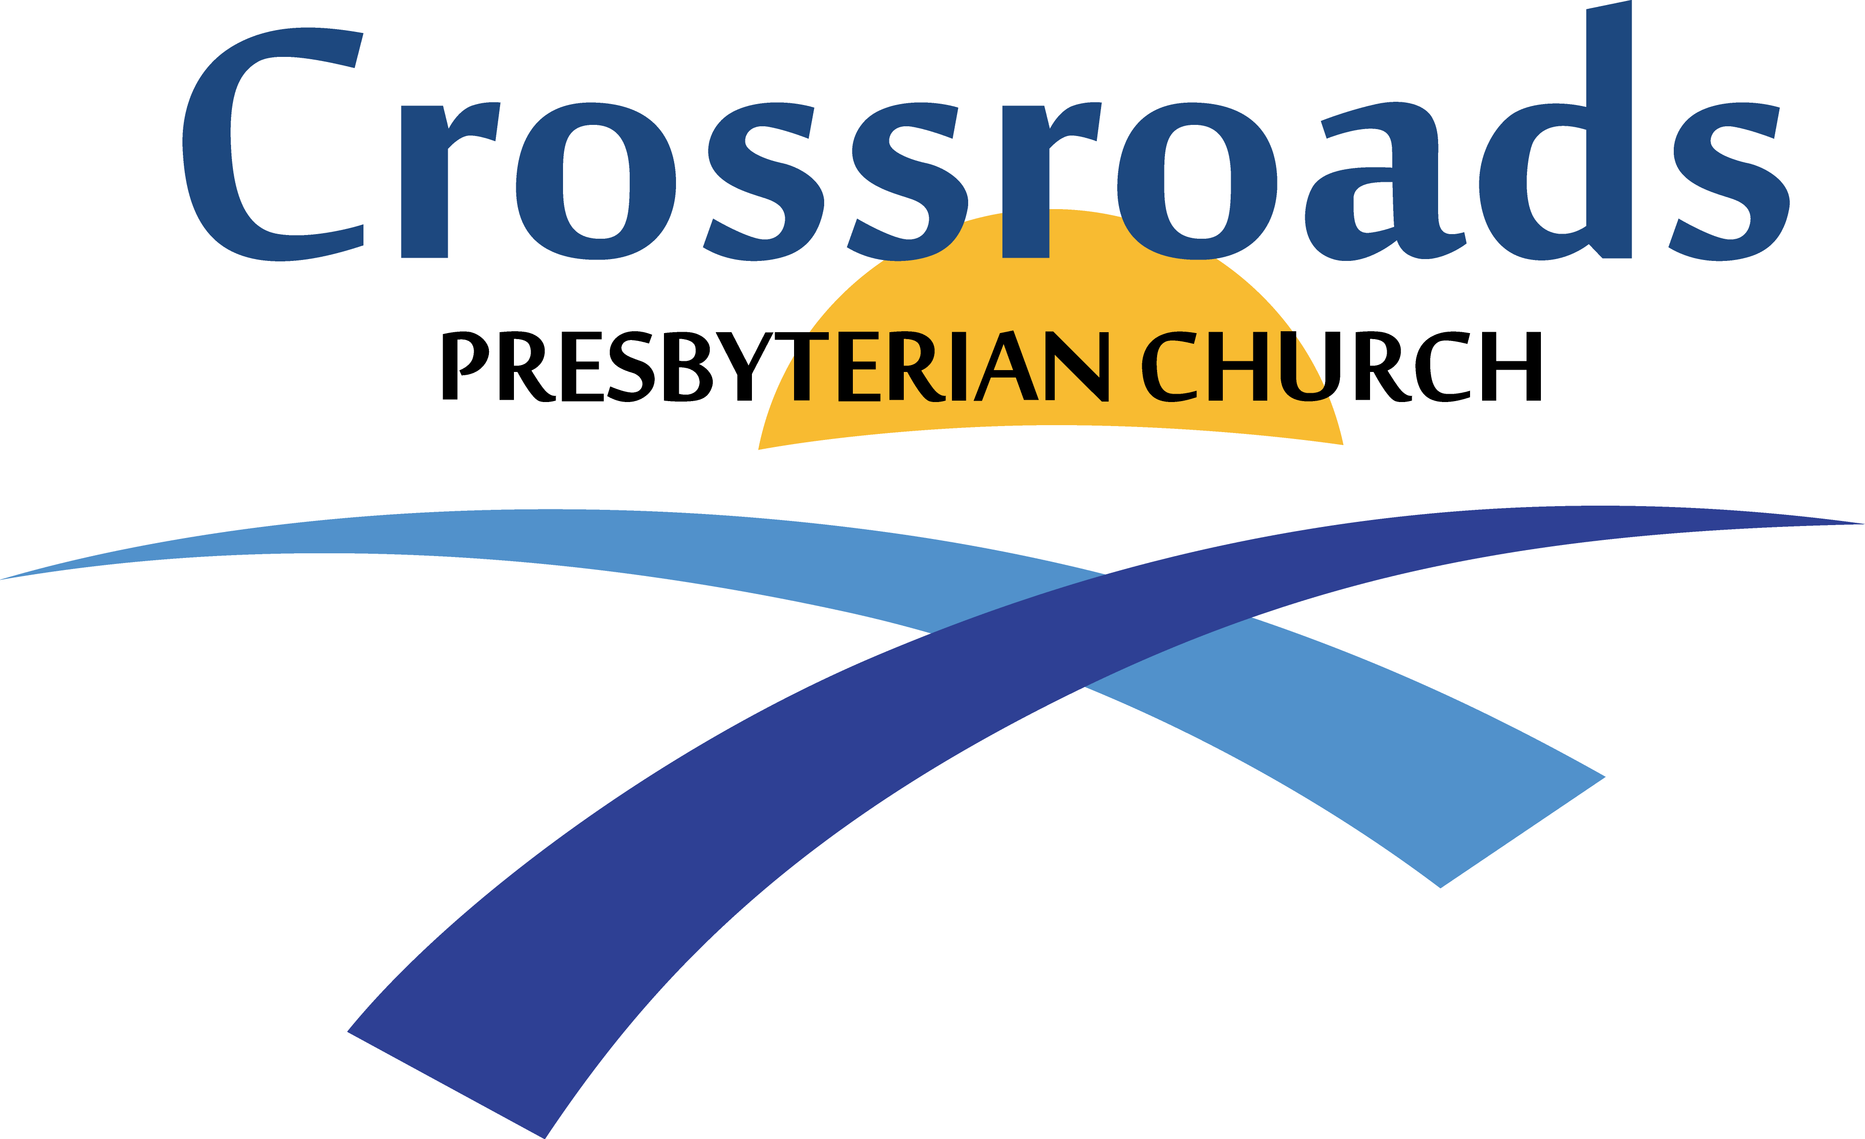

Third Sunday

April 21, 2024
11:00 A.M.

Lay Leader: Bill Small Worship Leader: Susan Small
Pianist: Kristi Helfen Drums: Ben Wilkinson
Percussion: Sam Jones

COMMUNITY NEWS, ANNOUNCEMENTS AND WELCOME

+CALL TO WORSHIP Psalm 24:1-2, 9-10
Leader: The earth is the Lord’s, and everything in it, the world, and all who live in it;
People: For He founded it upon the seas and established it upon the waters.
Leader: Lift up your heads, O you gates; lift them up, you ancient doors, that the King of glory may come in.
People: Who is He, this King of glory? The Lord Almighty – He is the King of glory.

OPENING HYMN Hymn No. 40 To God Be the Glory

+PRAYER OF CONFESSION (Unison)
Father God, we confess that we do not always represent You well in the way that we treat each other or others. Sometimes we don’t want to be selfless or obedient or even cooperative. Sometimes we are impatient or cranky. We are glad that You love us unconditionally, but sometimes we don’t feel up to loving others the same way. Forgive us, Lord. Help us to pay more attention to the promptings of the Holy Spirit, and transform us day by day as we seek to be more like You. *

+ASSURANCE OF PARDON Lay Leader
The Lord is compassionate and gracious, slow to anger,
abounding in love. He does not treat us as our sins deserve or
repay us according to our inequities. As far as the east is from
the west, so far has he removed our transgressions from us.
Psalm 103:8, 10, 12

JOYFUL OFFERING OF PRAISE
He Has Made Me Glad
Here I Am to Worship
+PASTORAL PRAYER

OAK STREET HEALTH PRESENTATION

RECOGNITION OF VISITORS
GRATEFUL GIVING OF OUR TITHES AND OFFERINGS
Please remember the Deacons Fund of Crossroads Church in your giving this week. Text and online giving available. See the website for information.

OFFERTORY MUSIC Kristi Helfen
Be Thou My Vision Traditional Irish Melody/Chung

OFFERTORY RESPONSE
Doxology
MINSTRY OF MUSIC Chancel Choir
“God Is Working”
By Carol Cymbala, with Susan Small soloist

CHILDREN’S CHURCH
(Children ages 4 & 5 and grades 1st-5th are dismissed to class)

+SCRIPTURE READING
If you are able, please stand for the reading of the Word of God.

Acts 4:1-22

Reader: The Word of the Lord
Response: Thanks be to God

SERMON Pastor Nicole
“Notable Signs”

MOMENT OF REFLECTION/CALL TO COMMITMENT

CLOSING HYMN Hymn No. 402
A Wonderful Savior is Jesus My Lord

BENEDICTION People: Amen

POSTLUDE Sing Praise to God Kirchengesange/Lopez

WHEN THE GATHERING ENDS, THE SERVICE BEGINS.
GO IN PEACE, TO LOVE AND SERVE THE LORD.
Hymn= Hymns for the Living Church.
(All music and words approved by CCLI License No. 58738)
+ No entry at this time. * Prayer by Susan Small

OPENING HYMN Hymn No. 40 TO GOD BE THE GLORY
To God be the glory, great things He hath done,
so loved He the world that He gave us His son,
who yielded His life an atonement for sin,
and opened the life gate that all may go in.
Refrain: Praise the Lord, praise the Lord, let the earth hear His voice!
Praise the Lord, praise the Lord, let the people rejoice!
Oh, come to the Father, through Jesus the son,
and give him the glory, great things he hath done.
Oh, perfect redemption, the purchase of blood,
to every believer the promise of God;
the vilest offender who truly believes,
that moment from Jesus a pardon receives.
Refrain
Great things He hath taught us, great things He hath done,
and great our rejoicing through Jesus the Son;
but purer, and higher, and greater will be
our wonder, our transport, when Jesus we see.
Refrain
Fanny J. Crosby

He Has made me glad

I will enter His gates
With thanksgiving in my heart
I will enter His courts with praise
I will say “this is the day
That the Lord has made
I will rejoice
For He has made me glad”

He has made me glad
He has made me glad
I will rejoice for
He has made me glad
He has made me glad
He has made me glad
I will rejoice for
He has made me glad

CCLI Song # 1493. Leona Von Brethorst © 1976 Maranatha Praise, Inc. (Admin. by Maranatha! Music) For use solely with the SongSelect Terms of Use. All rights reserved. www.ccli.com CCLI License # 58738

HERE I AM TO WORSHIP

Light of the world,
You stepped down into darkness,
Opened my eyes, let me see.
Beauty that made
This heart adore You,
Hope of a life spent with You.

Chorus:
Here I am to worship,
Here I am to bow down,
Here I am to say that You're my God.
You're altogether lovely,
Altogether worthy,
Altogether wonderful to me.

King of all days,
Oh so highly exalted,
Glorious in heaven above.
Humbly you came
To the earth You created.
All for love's sake became poor.

Chorus

I'll never know how much it cost
To see my sin upon that cross.
(Repeat)

Chorus
to….me…
(Tim Hughes...© 2000 Kingway's Thank You Music (Adm. BY EMI Christian Music Publishing)
CCLI License No. 58738)
CLOSING HYMN Hymn No. 402
A WONDERFUL SAVIOR IS JESUS MY LORD
A wonderful Savior is Jesus my Lord,
A wonderful Savior to me;
He hideth my soul in the cleft of the rock,
Where rivers of pleasure I see.
Refrain:
He hideth my soul in the cleft of the rock,
That shadows a dry, thirsty land;
He hideth my life in the depths of His love,
And covers me there with His hand,
And covers me there with His hand.
A wonderful Savior is Jesus my Lord,
He taketh my burden away,
He holdeth me up and I shall not be moved,
He giveth me strength as my day. (Refrain)
With numberless blessings each moment He crowns,
And filled with His fullness divine,
I sing in my rapture, oh, glory to God!
For such a Redeemer as mine. (Refrain)
When clothed with His brightness transported, I rise
To meet Him in clouds of the sky,
His perfect salvation, His wonderful love,
I’ll shout with the millions on high. (Refrain)
Francis J. Crosby

