Crossroads Presbyterian Church
Part of the Greater Atlanta Presbytery
of the Presbyterian Church (USA)
www.crossroads-pc.com

CHURCH STAFF
Nena Simonetti Administrative Assistant 770-469-9069
Patti Matthews Choir Director 770-469-9069
Latoria Hairston Youth Director 770-469-9069
Pastor Corey Lee Dir. Family Ministries 770-469-9069

LOCAL, NATIONAL & GLOBAL MISSIONS
Richard and Amanda Coleman TMS Global - Ethiopia
Margaret Garner Worldwide Discipleship Assoc. Atlanta
Willys & Suzette Goss-Geffrard Water Mission - Haiti
Jacqueline Huggins Wycliffe Bible Translators – Philippines
Gary Lane Mission Discovery
Focused Community Strategies Atlanta
Annette Smith Georgia Missions - Southern States, USA
Tony & Veronica Warner InterVarsity Christian Fellowship – SE

CURRENT RULING ELDERS
Class of 2024 Class of 2025 Class of 2026
Ephram Curry Michael Sofidiya Deloris Rose
Pamela Gruduah Mel Walker Maggie Stewart
Judie Morgan
Nancy Scott
Susan Small
John Matthews

CURRENT BOARD OF DEACONS
Class of 2024 Class of 2025 Class of 2026
Claudette Clark Roz Fuse-Hall Sam Jones
Byron James Ruth Cosby
Adolphe Denkey Mark Brown
Valerie Henry Dorothy Jones
Deborah Miller Sandy Lewis
Bill Lambert
Lysandra Brown

5587 Redan Road, Stone Mountain, GA 30088-3203
Tel: 770-469-9069 Fax: 770-469-7002
office@crossroads-pc.com

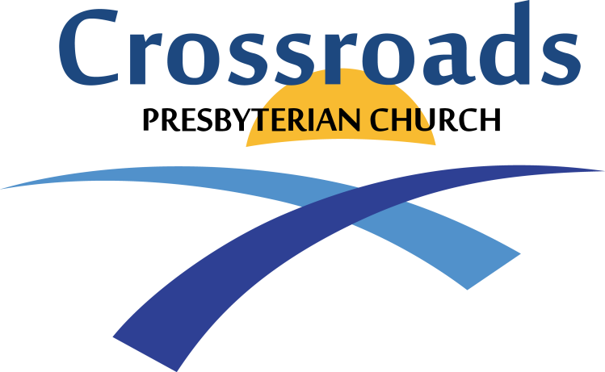

A Holy Communion Service
March 3, 2024
11:00 A.M.

Lay Leader: Bill Small Worship Leader: Susan Small
Pianist: Kristi Helfen Drums: Ben Wilkinson
Percussion: Sam Jones

GATHERING SONG

COMMUNITY NEWS, ANNOUNCEMENTS AND WELCOME

+CALL TO WORSHIP Rev. Sharon Gregory Leader: Baruch atah Adonai, Elohenu Melech ha’olam,
shehecheyanu, v’kivimanu, v’higiyanu la’zman
hazeh.
People: Blessed are You, Our God, Ruler of the universe, who has given us life and sustained us and enabled us to reach this season.
Leader: Hear, O Israel: the LORD our God, the LORD is One.
People: Love the LORD your God with all your heart and will all your soul and with all your strength.

OPENING HYMN Hymn No. 21
O Worship the King, All Glorious Above

+ CORPORATE PRAYER OF LAMENT (Unison)

OFFERING OF PRAISE
Through Our God
The Blood Will Never Lose Its Power

IPNC Update

+PASTORAL PRAYER

+APOSTLE’S CREED

RECOGNITION OF VISITORS

GRATEFUL GIVING OF OUR TITHES AND OFFERINGS
Please remember the Samaritan Fund Ministry to non-members in distress in your giving this week. Text and online giving available. See the website for information.

OFFERTORY Beneath the Cross of Jesus Kristi Helfen
Maker / Schram

OFFERTORY RESPONSE Yes, Lord, Yes

MINISTRY OF MUSIC Chancel Choir
“The Majesty and Glory of Your Name” (based on Psalm 8)
By Tom Fettke and Linda Lee Johnson

CHILDREN’S CHURCH
(Children ages 4 & 5 ONLY are dismissed to class)

INDRODUCTION OF THE SPEAKER Bill Small

+SCRIPTURE READING
If you are able, please stand for the reading of the Word of God.

Matthew 16:21 (NIV), Luke 22:7-8, 14-20 (NIV)

Reader: The Word of the Lord
Response: Thanks be to God

SERMON Chosen People Ministries
“Messiah in the Passover”

MOMENT OF REFLECTION/CALL TO COMMITMENT

SACRAMENT OF HOLY COMMUNION
Consecration of the Bread and Cup
Breaking of the Bread
Communion of the People

CLOSING HYMN Hymn No. 231
Free from the Law, O Happy Condition

BENEDICTION People: Amen

POSTLUDE Sanctifying Light – J. Southbridge Kristi Helfen

WHEN THE GATHERING ENDS, THE SERVICE BEGINS.
GO IN PEACE, TO LOVE AND SERVE THE LORD.

Hymn= Hymns for the Living Church.
(All music and words approved by CCLI License No. 58738)
+No entry at this time.

Apostles’ Creed

I believe in God the Father Almighty, Maker of Heaven and Earth; And in Jesus Christ His only Son our Lord; who was conceived by the Holy Ghost, born of the virgin Mary, suffered under Pontius Pilate, was crucified, dead and buried*; the third day He rose again from the dead; He ascended into heaven and sitteth on the right hand of God the Father Almighty, from thence He shall come to judge the quick and the dead;
I believe in the Holy Ghost; the Holy Christian Church**, the communion of saints; the forgiveness of sins, the resurrection of the body; and the life everlasting.
Amen.

* In the original Creed “He descended into Hell” is inserted
here.

** In the original Creed “the Holy catholic Church” is inserted
here.

Our Vision
To build committed disciples who love Jesus Christ and live their lives to fulfill God’s purposes.

Our Mission

Our mission is to be a nurturing multicultural
fellowship of growing Christians, committed to glorifying
God the Father, Son and Holy Spirit – through worship, proclaiming
Jesus Christ, witness and service in our communities,
the nation and the world.

CORPORATE PRAYER OF LAMENT (Unison)

We say we want to serve and please You, O God, but end up not doing as we say. We end up caring more for our comfort than for the needs of others, being too busy to finish what we start, not quite knowing how to make the world around us a better place. Help us, Lord.

We are appalled at the brokenness in our country: broken families, senseless acts of violence, people tricking others so they can steal from them, businesses that care for profit at the expense of people, systems that favor some and damage others, cynical elected officials who care more about staying in office than in accomplishing what they were elected to do. Where are the righteous?

Help us, Almighty God, not to be so overwhelmed that we do nothing. Guide us, both together and as individuals, to the good deeds that You have prepared for us. Help us to see the hurting and listen to them and love them with Your love.

We praise You, O Lord, for You are great! Your lovingkindness is steadfast and Your grace covers more than we ever expected. Through Jesus the Messiah You have saved us when we could do nothing to save ourselves. We entrust ourselves and our resources to You to use as You see fit.

OPENING SONG
O WORSHIP THE KING, ALL GLORIOUS ABOVE (#21)
O worship the King, all glorious above,
O gratefully sing His pow'r and His love;
Our Shield and Defender, the Ancient of Days,
Pavilioned in splendor and girded with praise.
O tell of His might, O sing of His grace,
Whose robe is the light, whose canopy space.
His chariots of wrath the deep thunder clouds form,
And dark is His path on the wings of the storm.
Thy bountiful care what tongue can recite?
It breathes in the air, it shines in the light;
It streams from the hills, it descends to the plain,
And sweetly distills in the dew and the rain.
Frail children of dust, and feeble as frail,
In Thee do we trust, nor find Thee to fail;
Thy mercies how tender! how firm to the end!
Our Maker, Defender, Redeemer, and Friend.
Amen. William Kethe

OFFERTORY RESPONSE
YES, LORD, YES
I’ll say yes, Lord, yes to Your will and to Your way.
I’ll say yes, Lord, yes; I will trust You and obey.
When Your Spirit speaks to me,
With my whole heart I’ll agree,
And my answer will be yes, Lord, yes.

Lynn Keesecker

VICTORY SONG

Through our God
We shall do valiantly.
It is He
Who shall tread down our enemy.
We'll sing and shout the victory:
Christ is King!
For God has won the victory
And set His people free.
His Word has slain the enemy.
The earth shall stand
And see that through our
God we do shall valiantly.

(Dale Garratt...© 1979 Scripture In Song (a div. of Integrity Music, Inc.) CCLI License No. 58738)

The Blood Will Never Lose Its Power

The blood that Jesus shed for me
'Way back on Calvary
The blood that gives me strength
From day to day
It will never lose its pow'r

Chorus
It reaches to the highest mountain
It flows to the lowest valley
The blood that gives me strength
From day to day
It will never lose its pow'r

It soothes my doubt and calms my fears
And it dries all my tears
The blood that gives me strength
From day to day
It will never lose its pow'r

Chorus

CCLI Song # 11885. Andraé Crouch © 1966 Manna Music, Inc. (Admin. by ClearBox Rights, LLC) For use solely with the SongSelect Terms of Use. All rights reserved. www.ccli.com CCLI License # 58738

HYMN OF THE MONTH
FREE FROM THE LAW, O HAPPY CONDITION (#231)
Free from the law, O happy condition,
Jesus hath bled, and there is remission;
Cursed by the law and bruised by the fall,
Grace hath redeemed us once for all.
Refrain:
Once for all--O sinner, receive it;
Once for all--O brother, believe it;
Cling to the cross, the burden will fall,
Christ hath redeemed us once for all.
Now we are free--there's no condemnation,
Jesus provides a perfect salvation;
"Come unto Me," O hear His sweet call,
Come, and He saves us once for all. (Refrain)
Children of God, O glorious calling,
Surely His grace will keep us from falling;
Passing from death to life at His call,
Blessed salvation once for all. (Refrain) Philip P. Bliss

